Nexora member portal login and onboarding
Document 24 of the Nexora learning guides
Source snapshot 14 October 2026 at 06:41 UTC
Understand member sign-in, optional self-registration and organisation access requests.

Recognise the screen and its scope
Open /portal, /portal/signup. CRM routes use port 3017; member routes use 3018; public website routes can use 3019. Brackets name a route parameter, not text to paste into a browser. Choose a real record or site id from the application.
This guide covers Member login and logout; Published sign-in branding; Optional self-registration; Association host mapping; Contact and personal portal access creation; Company access requests and staff review.
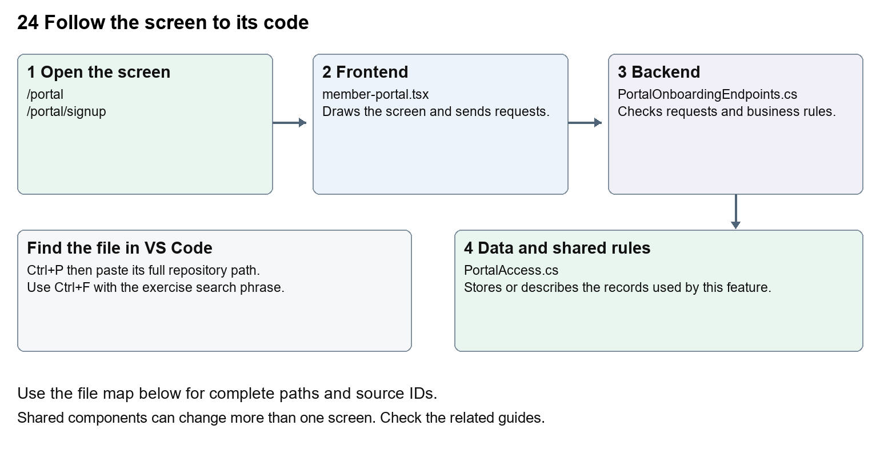
The diagram shows the file roles. The full paths below are what you paste into Ctrl+P.

Find the files in VS Code
Role | File and source ID | What it does
Screen | S0123 member-portal.tsx | Main UI or route for this topic
Server | S0402 PortalOnboardingEndpoints.cs | Endpoints or server rules
Data | S0376 PortalAccess.cs | Data shape or persistence structure

Screen S0123
apps/web/src/features/portal/member-portal.tsx
Server S0402
backend/src/Modules/Nexora.Modules.Identity/PortalOnboardingEndpoints.cs
Data S0376
backend/src/Modules/Nexora.Modules.Identity/Domain/PortalAccess.cs
The complete HTML manual opens these source IDs inside its Source library. The Word manual shows short labelled extracts so you can learn the flow before reading large files. Each individual Markdown guide includes its complete primary files after the walkthrough.

Follow the request and the records
1. PortalLayout preserves the member shell while the route changes.
2. The page loads public appearance and onboarding availability for its mapped association host.
3. Login or enabled registration uses the portal API helper and portal CSRF endpoint.
4. The Identity module creates or checks permitted member access.
5. Company access is requested and reviewed separately from personal membership.

Read the code with an explanation
Staff and member sessions have separate purposes and access checks. Self-registration is governed by published onboarding settings and host mapping. A new personal profile does not immediately grant membership or company authority. Organisation requests can be reviewed by staff, who can create the relevant relationship and explicit grant. Failed or late requests are guarded so they do not restore an expired session.
Source reference S0123 apps/web/src/features/portal/member-portal.tsx
Selected opening lines with their original numbers. The complete file is in the HTML source library.
0001 "use client";
0002 import { useCallback, useEffect, useRef, useState } from "react";
0003 import { MemberDashboard } from "./member-dashboard";
0004 import { defaultPresentation, defaultPortalDesign, portalDesignStyle, type PortalPresentation } from "./presentation";
0005 import styles from "./portal.module.css";
0006 import { portal } from "./api";

The import lines lead to shared components and helpers. Start at the exported component or route function; follow the request helper to the server rather than assuming the whole feature lives in this file.
Source reference S0402 backend/src/Modules/Nexora.Modules.Identity/PortalOnboardingEndpoints.cs
Extract from source line 29. A fragment from a long line is shown without the rest of that line.
0029 portal.MapGet("/onboarding", async (IPortalRegistrationDirectory directory, CancellationToken ct) =>

On the server, look for MapGet to load records, MapPost to create or perform an action, MapPut or MapPatch to change data, and RequireAuthorization for permissions. Some shared methods register endpoints indirectly. Find SaveChangesAsync to see the database write. A request method alone does not tell you every side effect.
Source reference S0376 backend/src/Modules/Nexora.Modules.Identity/Domain/PortalAccess.cs
Selected opening lines with their original numbers. The complete file is in the HTML source library.
0001 namespace Nexora.Modules.Identity.Domain;
0003 // Explicit access grant. CRM relationships and email addresses never imply this grant.
0004 public sealed class PortalAccess
0005 {
0006 public Guid Id { get; set; } = Guid.NewGuid();
0007 public Guid TenantId { get; set; }

Follow model fields to their request names and database mapping. An id points to a particular record. A tenant id limits the organisation. A version or concurrency stamp protects newer edits. Some model files describe contracts rather than tables; check the owning DbContext before assuming storage.

Make or trace your first change
1. Press Ctrl+P and open apps/web/src/features/portal/member-portal.tsx.
2. Press Ctrl+F and search for Welcome to your member portal. In this snapshot it appears at line 88.
3. Change this fallback sign-in heading only. Refresh /portal while signed out. Use CRM settings for stored branding; this source change affects the hardcoded heading.
4. Replace only Welcome to your member portal with Welcome to your community portal in that intended location. Keep quotes, tags, JSON keys and routes intact.
5. Save with Ctrl+S. Inspect Problems and the local screen. Review the diff and restore the original text when you finish practising.
Extract from source line 88. A fragment from a long line is shown without the rest of that line.
0088 gningUp ? "Join your community" : "Welcome to your member portal"}</h1>

These exercises have not been applied to the application. Their search phrases are verified against the captured source. Line numbers can move; the phrase and file path are your main navigation aids.

Check a change and diagnose problems
Confirm the original screen still loads, the changed words appear in the intended place, and another screen using the same component still behaves correctly. If an action fails, inspect the browser Network response, the relevant helper and server validation message. Use the common error table at the beginning of the manual. Reload on a version conflict instead of removing the version check.
A syntax error after a text edit usually means a quote, brace or closing tag changed. Compare your diff with the original. An unchanged browser result can mean the wrong port, a saved published configuration overriding a default, or a running API that has not reloaded.

Understand the current limits
Current local portal identity is Development-only. Production identity, email verification and password recovery remain future scope. New registration requires enabled published settings and a correctly mapped association domain.

Continue learning
Related guides 01 Nexora login page, 20 Nexora administration and access, 25 Nexora member portal journeys, 26 Nexora portal management.

